How does the Curiosity Rover
Nuclear Battery work?
The Curiosity Rover Nuclear Battery is one of the best feature of the latest Mars Rover. It is a huge and necessary upgrade compared the previous generation of Mars Exploration Rovers Spirit and Opportunity.
It contains about 5kg (10 pounds) of plutonium-238 (non explosive), and can power the rover for at least 14 years. This motor will supply energy to the Mars Science Laboratory night and day for as long as it can move.
Let's check out how it all works, where it was used before and compare it to other solutions like the more traditional solar panels.

How Does the Curiosity Rover Nuclear Battery Work?
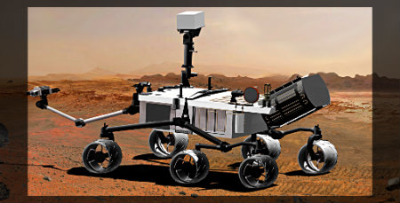
The nuclear battery is the black 'tail'
Photo courtesy of NASA
First, I'll tell you its real name: NASA calls it the Multi-Mission Radioisotope Thermoelectric Generator, or MMRTG. And the principle is quite simple: the radioactive plutonium generates heat by splitting naturally into more stable atoms. The heat is used to 'cook' a thermocouple that generates electricity to the whole system.
Okay, so just like you, my next question was: what is a thermocouple? When you make 2 different metals touch each other, it creates a tension (voltage) that is dependant on the temperature. It is very reliable to calculate the tension from the temperature if you use the right metals. Now, if you want to make a battery, you just need to have 2 junctions at 2 different temperatures. You can get more info from Wikipedia's page on thermocouple. That's it: the Plutonium generates very regular heat over several years, the heat hits up the warm part of the thermocouple, and the thermocouple generates electricity to the system.
The whole system is safe enough and small enough that even if the rocket explodes at launch, the Plutonium would most likely not be released, and it's release wouldn't even be a problem.

Has it been used before?
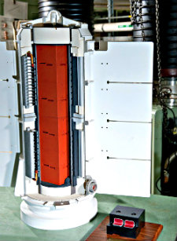
Look inside nuclear battery
Photo courtesy of NASA
Yes it has! It has been used since the Apollo mission. The first time I heard about the Curiosity Rover nuclear battery, I was thinking this must be top notch technology. What a surprised I had when I saw it has been used for more that 40 years already. It's never too late to learn how it works anyway.
Let's quote NASA: "The Apollo missions to the moon, the Viking missions to Mars, and the Pioneer, Voyager, Ulysses, Galileo, Cassini and New Horizons missions to the outer solar system all used radioisotope thermoelectric generators."
Still, the Curiosity Rover nuclear battery is a new generation battery that is used for the first time on this Mars rover. As NASA says, it is more flexible and can be used on a wide variety of missions since they have better control over the tension delivered by the new system.
In particular, only the new generation can deliver 14 years of energy within a 45kg, 60X60X60cm box. Yes, it is not much different from the boiler in your house, but so much more powerful.

Let's compare to Solar Panels
Why didn't they send the Mars Science Laboratory with solar panels like the 2 previous generations of Mars rovers?
In short, NASA wanted to make this mission better and faster. The 2 main drawbacks of solar panels is that they don't work during the night, and they don't work during the Martian winter. One consequence is that the Mars Exploration Rovers couldn't work for more that half of the time.
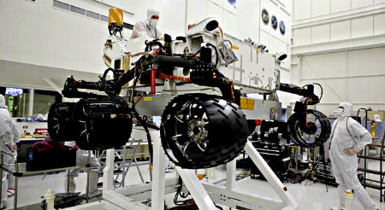
The Curiosity rover is bigger, needs more power
Photo courtesy of NASA
The Curiosity Rover Nuclear Battery will supply the system with constant power, allowing it to work as much as needed, all year long for as long as 14 years. Imagine the difference when the rover is traveling from one point to another if it doesn't have to stop every night.
Another thing is that the new rover is much bigger and holds more experimental tools, and can go a little faster. All in all, the power supply from the nuclear battery is nearly 3 times more than the solar panels (in day time).
All these are clear good reasons for the Mars Science Laboratory to go to Mars with some Plutonium in its backpack.

